Name: ________________________________ Period: ____________ Date: ______________
COLOR BY CODES USING CUSTOMARY UNITS OF MEASUREMENT
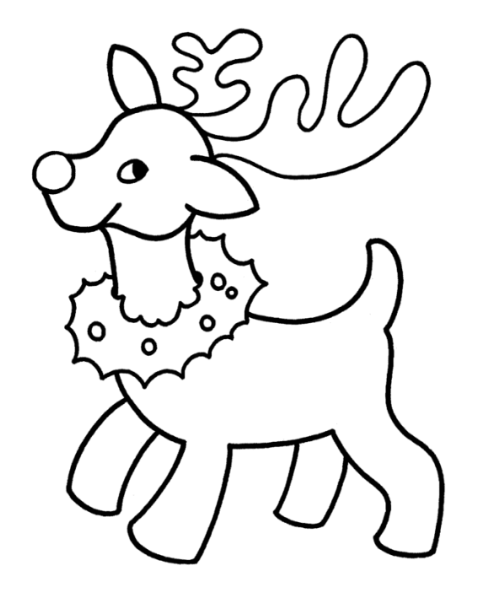
5
Kg
10560
Kg
tons
tons
32
Meters
Foot
$$1.25$$
$$36 in.$$
$$32$$
$$10000$$

Answer the questions - find your answer on the Reindeer - color according to your answers.

- Converting 3 feet to inches gives ___________. (BROWN)
- 20 oz. = ___________ lb. (GREY)
- $10 c=$ __________ pt. (RED)
- The appropriate unit of measurement for the length of the table is ___________. (BROWN)
- Which of these is not a customary unit of length? (BLACK)

  - Inches
  - Foot
  - Meters
  - None of these
- 1 qt = ________ fluid oz. (LIGHT BROWN)
- The appropriate unit of measurement for the weight of a whale is ___________. (BROWN)
- Which of these is not a customary unit of weight? (BROWN)

  - Kg
  - Lbs.
  - T
  - None of these
- 2 miles = __________ feet. (YELLOW)
- 5 Tons = _________ lbs. (BROWN)

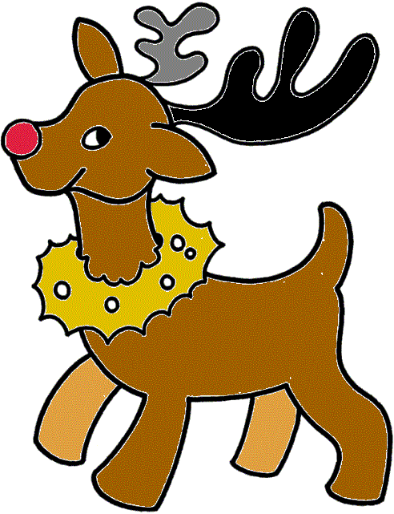 | Answers:  - $36 in.$  - 1.25  - 5  - Foot  - Meters  - 32  - 41  - Kg  - 10560  - $10000$

