Rational Numbers
Directions: Answer each question. Use your answer to navigate through the maze. Show your work.
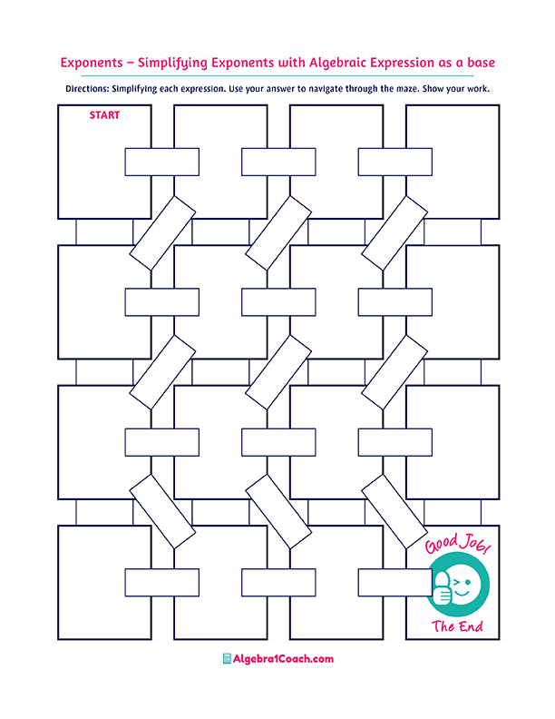
Identify the
irrational number!

Identify the irrational number!
Identify the rational number!
$$2\frac{2}{5}$$
Which of the following numbers is a whole number?
Which of the following numbers is rational?
$-2.4$ as a fraction is:
$$1.8$$
$$1.7$$
$$0.2$$
$$-2\frac{1}{5}$$
$$1.3535……$$
$$\sqrt{36}$$

$4$ as a fraction is:
$12$ as a fraction is:

Which of the following numbers is rational?
Which of the following numbers is a whole number?
$$\frac{2}{24}$$

$$\frac{24}{2}$$
$$2.3333..$$
Which of the following numbers is irrational?
Which of the following numbers is an integer?
$$0.25$$
$$\frac{15}{3}$$
$$\frac{6}{4}$$
It is a rational and an integer.
$\frac{4}{16}$ as a decimal is:

$$\sqrt{64}$$
$$-\sqrt{9}$$

$$1.\overline{3}$$
$$π$$
$$-3$$
$\frac{4}{3}$ as a decimal is:
$$\sqrt{13}$$
$$\sqrt{5}$$
$$\sqrt{25}$$
$$-8.\overline{4}$$
$$\sqrt{144}$$
$$-\sqrt{4}$$
$$0.\overline{6}$$
$$\sqrt[3]{4}$$
$$\sqrt{13}$$
$$\frac{16}{4}$$

$$2.\overline{1}$$
$$\sqrt{7}$$
$$\sqrt{24}$$
$$\sqrt{3}$$
$$0.\overline{25}$$

