Scientific Notation
Directions: Find the correct answer. Use your answer to navigate through the maze. Show your work.
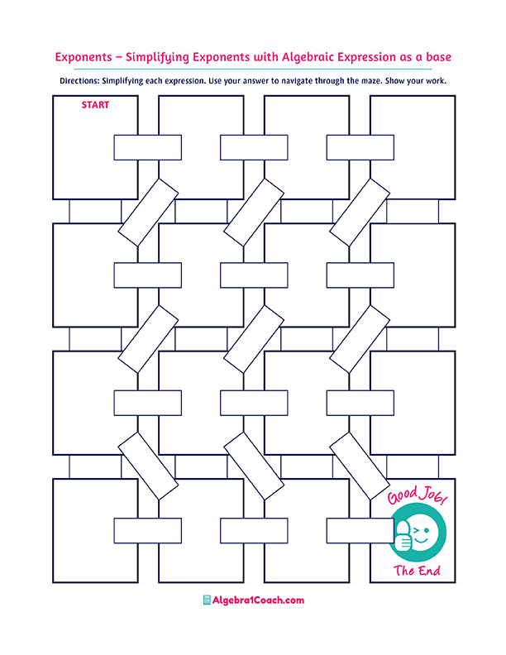
$$0.34$$

$$1.1×{10}^{1}$$
$$-1$$

$$0.0013$$

$$1.02×{10}^{4}$$

$$1.02×{10}^{-2}$$

$$3.4×{10}^{0}=$$
$$1.2×{10}^{-3}$$

$$3×{10}^{-2}$$

$$2.5×{10}^{-1}$$

$$9×{10}^{5}$$
$${10}^{5}$$
$$0.002$$
$$10.2=$$

$$0.0000002=$$

$$230=$$

$$23,000=$$
$$1.2×{10}^{-3}$$

$$1.02×{10}^{-1}$$

$$1.02×{10}^{1}$$
$$300=$$
$$2×{10}^{-7}$$
$$0.02×{10}^{-4}$$

$$1.02×{10}^{5}$$

$$11.1=$$
$$3×{10}^{2}$$

$$8,010$$
$${8.01×10}^{3}=$$
$$0.00013$$

$$900,000=$$
$$1.3×{10}^{-5}=$$

$$0.25=$$

$$800,00$$

$$34$$

$$0.000013$$
$$0.1×{10}^{1}$$
$$80,000$$
$$8×{10}^{4}=$$
$$3.4$$

$$801$$

$$2.3{×10}^{-4}$$

$$80,100$$

$$8,000$$
$$0.0012=$$

$${1×10}^{0}=$$
$$2×{10}^{-3}=$$

$$2.3{×10}^{4}$$
$$1$$
$$0.0002$$

