Operations with Numbers in Scientific Notation
Directions: Find the correct answer. Use your answer to navigate through the maze. Show your work.
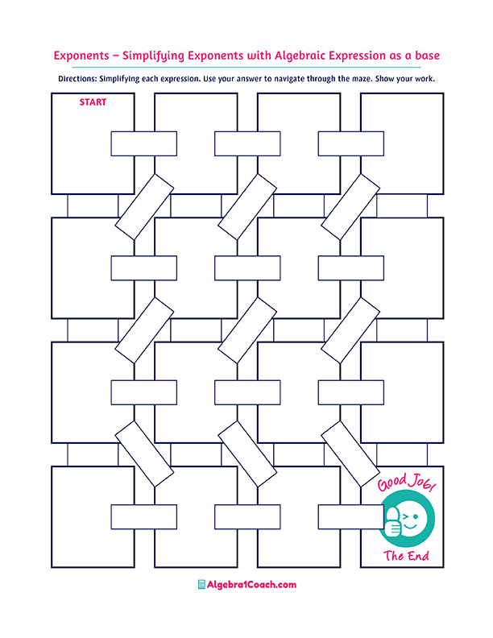
$$1.3×{10}^{6}$$

$$-1.2$$

$$16$$

$$1.02×{10}^{-2}$$

$$\left({4×10}^{2}\right)×0.003$$
$$7,300$$

$$2×{10}^{-7}$$
$$4,567-\left(2×{10}^{2}\right)$$

$$300×\left(2×{10}^{15}\right)$$
$$\left(2.3×{10}^{6}\right)-{10}^{6}$$
$$5×{10}^{2}$$

$$\frac{7×{10}^{12}}{1.4×{10}^{10}}$$

$$1.2$$

$$900-{10}^{3}$$
$$5.57$$
$$5.6-\left(3×{10}^{-2}\right)$$
$$-{10}^{2}$$

$$\frac{2×{10}^{-5}}{{10}^{-6}}$$
$$\left(4×{10}^{2}\right)-20$$

$$1.6×{10}^{3}$$

$$\frac{3,200}{0.2×{10}^{3}}$$

$$\left({4×10}^{-3}\right)+234$$

$$\left({8×10}^{3}\right)-\left({7×10}^{2}\right)$$
$$5$$

$$\frac{2.5×{10}^{-2}}{5×{10}^{-3}}$$

$$3-\left(2×{10}^{2}\right)$$

$$197$$
$$7.3×{10}^{1}$$

$$6×{10}^{15}$$

$$1.02×{10}^{-1}$$

$$1.02×{10}^{1}$$
$$1.6×{10}^{6}$$

$$6×{10}^{17}$$

$$7.3$$
$$380$$

$$2.6×{10}^{-2}$$
$$3.8×{10}^{3}$$
$${10}^{5}$$
$$0.5$$
$$20$$
$$45$$

$$7.3×{10}^{2}$$

$$2.3{×10}^{0}$$

$$0.34$$

$$2×{10}^{1}$$
$$\left(5×{10}^{1}\right)-5$$
$$234.004$$
$$12$$
$$-197$$

