Operations with Rational Numbers
Directions: Find the correct answer. Use your answer to navigate through the maze. Show your work.
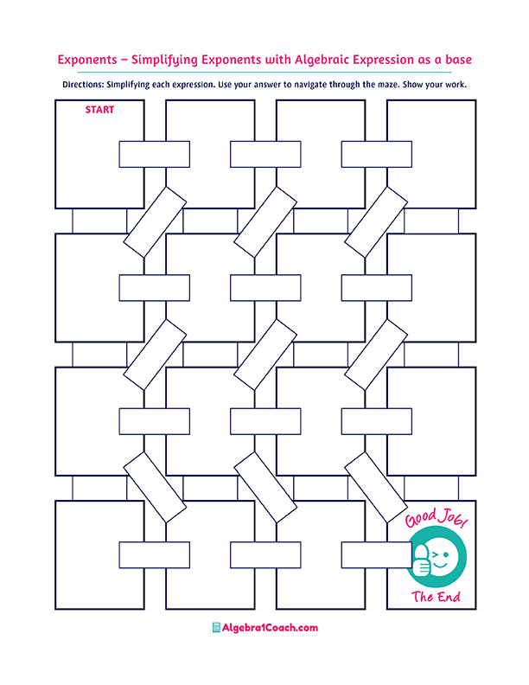
$$-0.75$$

$$1.2\overline{6}$$

$$\frac{1}{5}$$

$${\left( \frac{1}{2}\right)}^{2}+\left(-\frac{4}{12}\right)=$$
$$-3.55+4.2=$$
$$4$$
$$7.24$$
$$2\frac{2}{3}-1\frac{2}{5}=$$
$$-3.08$$
$$-3.22+4.2=$$
$$\frac{1}{5}$$
$$1\frac{2}{8}$$
$$7.4×\left(-0.2\right)=$$
$$\frac{1}{2}$$
$$-1.1÷\left(-2.2\right)=$$
$$-\frac{1}{8}$$

$$12.4×\left(-2\right)=$$
$$29.14$$
$$9.4×\left(-3.1\right)=$$

$$1.4×\left(-2.2\right)=$$
$$\frac{1}{12}$$
$$-\frac{1}{12}$$

$$0.65$$

$$\frac{2}{5}+\left(-\frac{1}{3}\right)=$$

$$\frac{1}{15}$$
$$\frac{8}{14}÷\left(\frac{-4}{7}\right)=$$
$$\frac{1}{5}×\frac{15}{9}=$$
$$\frac{3}{10}÷\left(\frac{-6}{15}\right)=$$
$$-2\frac{2}{5}×\left(-\frac{10}{6}\right)=$$

$$0.\overline{3}$$
$$0.28$$
$$\frac{1}{8}$$
$$2.48$$

$$\frac{2}{24}$$

$$2\frac{1}{4}÷\left(-18\right)=$$
$$24.8$$
$$-1$$
$$7.65$$
$$0.98$$
$$3.56$$
$$-0.98$$
$$-0.\overline{15}$$
$$0.\overline{6}$$
$$2.42$$
$$1.48$$

$$2.\overline{1}$$
$$1.3$$
$$-24.8$$

