Converting Fractions and Decimals
Directions: Find the correct answer. Use your answer to navigate through the maze. Show your work.
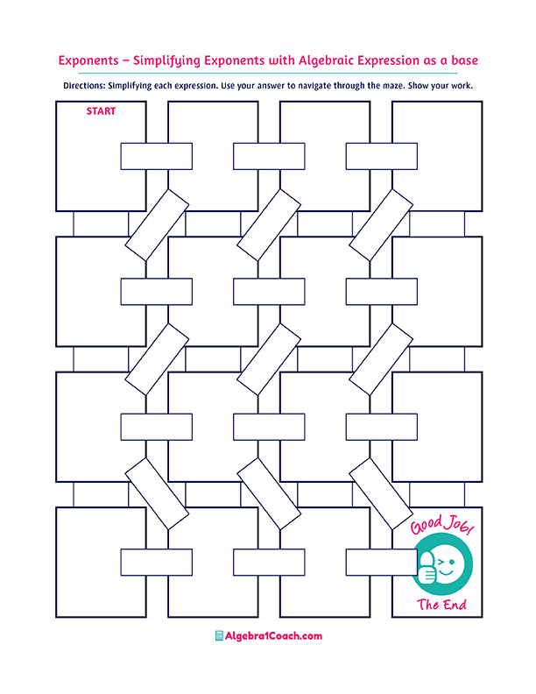
$$1\frac{9}{16}=$$
$$-2.25$$

$$\frac{152}{99}$$
$$-7\frac{1}{9}$$

$$2.5$$
$$7\frac{3}{9}$$

$$7\frac{4}{9}$$
$$7\frac{1}{9}$$
$$3.06=$$

$$-0.8$$

$$-0.125$$

$$3\frac{1}{12}$$

$$-2\frac{1}{4}=$$
$$\frac{2}{20}$$
$$0.2=$$
$$0.2222…$$
$$0.0202..$$
$$\frac{2}{99}=$$
$$1\frac{9}{16}=$$
$$3\frac{2}{50}$$
$$3\frac{3}{50}$$
$$\frac{3}{250}$$
$$0.012=$$

$$-\frac{4}{32}=$$
$$4.\overline{2}=$$
$$-2.5$$
$$2.\overline{2}$$

$$2\frac{2}{9}=$$
$$7.111..=$$
$$\frac{1}{5}$$
$$9.4=$$

$$1.\overline{53}=$$
$$0.65$$

$$\frac{2}{125}$$
$$\frac{2}{15}=$$
$$-\frac{10}{4}=$$

$$0.28$$
$$1.\overline{56}$$

$$\frac{2}{24}$$

$$1.5\overline{6}$$
$$0.1\overline{3}$$
$$3.56$$
$$-2.\overline{15}$$
$$0.\overline{24}$$
$$0.\overline{42}$$
$$1.48$$

$$1.\overline{5625}$$
$$1.5625$$

