**Identifying Irrational Numbers**

**Directions: Find the correct answer. Use your answer to navigate through the maze. Show your work.**

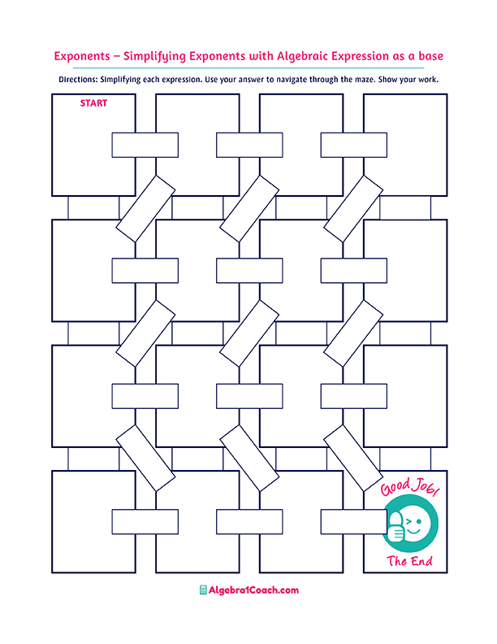

**Irrational Number**

$$\frac{4}{16}$$

$$2.3$$

$$\sqrt{4,225}$$

$$\sqrt{\frac{4}{12}}$$

$$2.\overline{3}$$

**Repeating Decimal**

$$-0.2$$

**Rational Number**

$$2\frac{21}{10}$$

$$2\frac{3}{10}$$

**Rational Number**

**Terminating Decimal**

$$-16$$

$$65$$

**Terminating Decimal**

**Irrational Number**

**Repeating Decimal**

**Terminating Decimal**

$$2\frac{21}{1,000}$$

**Terminating Decimal**

$$4.123$$

**Irrational Number**

**Repeating Decimal**

**Repeating Decimal**

$$5\frac{12}{90}$$

**Terminating Decimal**

**Rational Number**

**Irrational Number**

$$1.6$$

$$7\frac{1}{9}$$

$$\sqrt{121}$$

$$-\sqrt{256}$$

$$0.\overline{25}$$

$$0.25$$

$$0.2\overline{1}$$

$$-\frac{1}{2}$$

$$5.\overline{12}$$

$$4.\overline{2}$$

$$\sqrt{24}$$

$$\sqrt{17}$$

$$2.21$$

$$13.\overline{3}$$

$$\frac{65}{3}$$

$$16$$

$$65.\overline{3}$$

$$-16.\overline{1}$$

$$4.5$$