Identifying Irrational Numbers
Directions: Find the correct answer. Use your answer to navigate through the maze. Show your work.
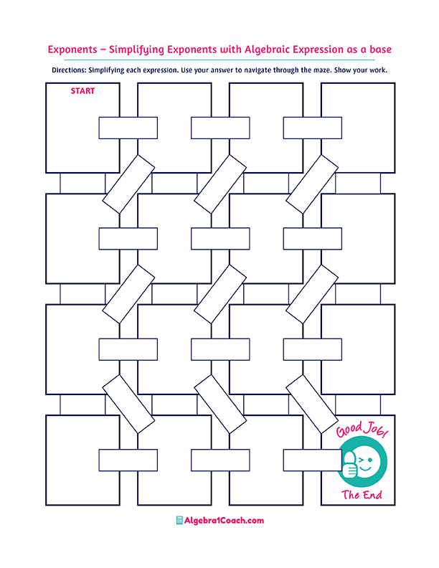
$$4.\overline{2}$$

$$\sqrt{\frac{4}{12}}$$

Irrational Number

Terminating Decimal

Irrational Number
Rational Number
Terminating Decimal
Irrational Number
Repeating Decimal

$$-0.2$$
Rational Number

$$2\frac{21}{10}$$

$$2\frac{3}{10}$$

Rational Number

Terminating Decimal

$$-16$$
$$65$$
Terminating Decimal

Repeating Decimal

$$2\frac{21}{1,000}$$

Terminating Decimal

$$4.123$$
Repeating Decimal
Repeating Decimal
$$5\frac{12}{90}$$

Irrational Number
$$2.3$$
$$1.6$$
$$7\frac{1}{9}$$
$$\sqrt{121}$$

$$-\sqrt{256}$$
$$\sqrt{4,225}$$
$$0.\overline{25}$$
$$0.25$$
$$\frac{4}{16}$$
$$2.\overline{3}$$
$$0.2\overline{1}$$

$$-\frac{1}{2}$$
$$5.\overline{12}$$
$$\sqrt{24}$$
$$\sqrt{17}$$
$$2.21$$

$$13.\overline{3}$$
$$\frac{65}{3}$$
$$16$$
$$65.\overline{3}$$
$$-16.\overline{1}$$
$$4.5$$

