Properties of Irrational Numbers
Directions: Find the correct answer. Use your answer to navigate through the maze. Show your work.
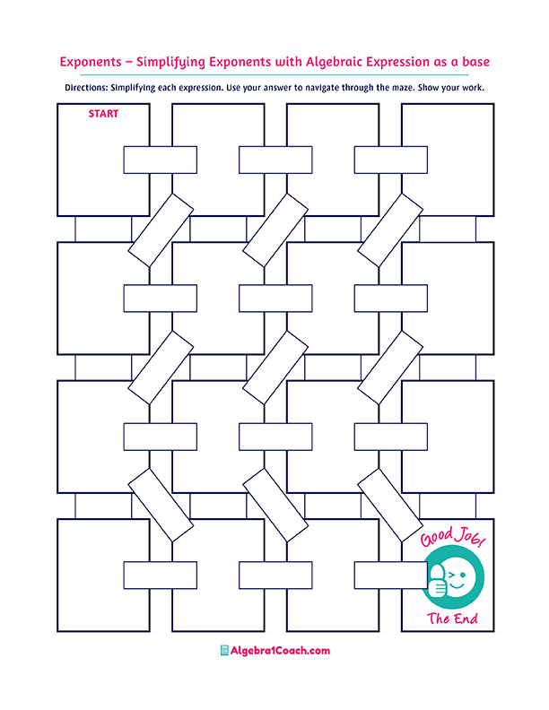
Irrational Number

$$π+15$$

$$6.3$$
$$-\sqrt{144}÷6$$
Irrational Number

Rational Number
Irrational Number
Rational Number

$$6.\overline{3}$$

$$2.6$$

$$-0.25$$

Irrational Number

$$2$$
$$1$$
Repeating Decimal

$$1$$

$$-1$$
Repeating Decimal

$$2$$

$$5$$

Irrational Number
$$\frac{4}{16}-0.50$$
$$2.3+2.\overline{3}$$

=2.3
$$\sqrt{4}+\sqrt[3]{-8}$$
$$\sqrt{\frac{64π}{16π}}$$

$$3+\sqrt{7}$$
$$-4$$
Irrational Number

Irrational Number
$$-2$$
$$0$$
Terminating Decimal

Repeating Decimal

Terminating Decimal

Terminating Decimal

Repeating Decimal
$$\sqrt{169}-\sqrt{16}$$

$$0.25$$
$$-\frac{1}{2}÷12.1$$
$$2.\overline{1}×3$$
$$1.\overline{3}×\frac{4}{3}$$
$$\sqrt{17}÷\left(-\sqrt{17}\right)$$
$$\sqrt{5}×\sqrt{5}$$
$$13.\overline{3}+\sqrt{11}$$
$$\frac{6}{3}-\sqrt{5}$$
$$-32$$
$$-2$$
$$4.5$$

