Comparing and Ordering Irrational Numbers on a Number Line
Directions: Find the correct answer. Use your answer to navigate through the maze. Show your work.
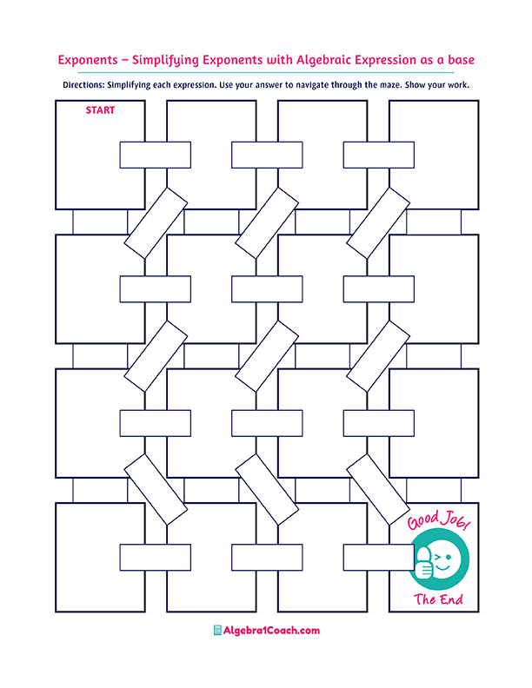
$$1.5π≈$$
$$4$$

Which of the following
number
is less
then $\sqrt{14}$?
Which number
is closest to the value of
$2\sqrt{2}$?

Which number
is closest to the value of
$-3\sqrt{6}?$
$$5$$

Which number is closest to the value of
$\sqrt{18}$?

$$10$$

$$-6$$
$$9$$
$$3$$
$$4.3$$

$$\sqrt{216}$$
$$-\sqrt{145}≈$$
$$9.7$$

$$11$$

What is the approximate value of
$\sqrt[3]{81}$?

$$12$$

$$9$$
What is the approximate value of
$\sqrt{101}$?

Which of the following number
is less
then $\sqrt{99}$?

$$11$$

$$\sqrt{122}≈$$
$$15$$

What is the approximate value of $\sqrt{213}$?
$$-3$$

$$3.5$$

$$4.8$$

Which of the following number is greater
then $\sqrt{12}$?

=2.3
$$2$$
$$4$$
$$3$$

$$-7$$
$$-18$$
$$5$$
$$6$$
$$\sqrt{33}≈$$

$$6$$
$$14$$
$$14.6$$

$$\sqrt[3]{-216}$$

$$-4$$
$$-12$$
$$14$$
$$3.8$$
$$12$$
$$3$$
$$9.9$$

