**Comparing and Ordering Irrational Numbers on a Number Line**

**Directions: Find the correct answer. Use your answer to navigate through the maze. Show your work.**

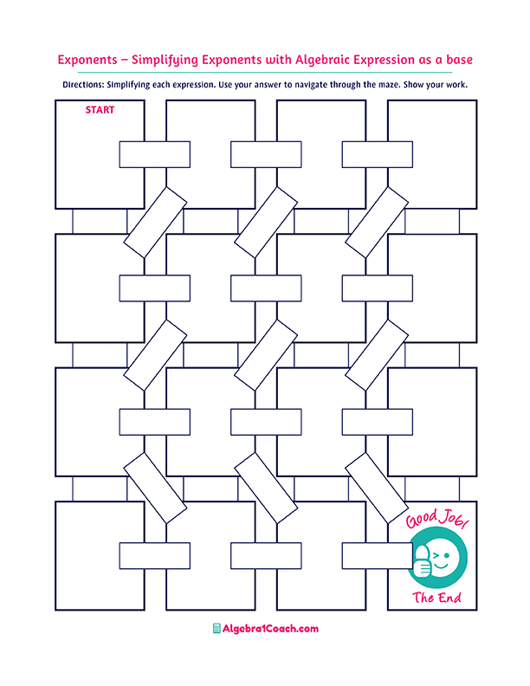

$$1.5π≈$$

$$4$$

**Which of the following**

**number**

**is less**

**then $\sqrt{14}$?**

**Which number**

**is closest to the value of**

$2\sqrt{2}$**?**

**Which number**

**is closest to the value of**

$-3\sqrt{6}?$

$$5$$

**Which number is closest to the value of**

$\sqrt{18}$**?**

$$10$$

$$-6$$

$$9$$

$$3$$

$$4.3$$

$$\sqrt{216}$$

$$-\sqrt{145}≈$$

$$9.7$$

$$11$$

**What is the approximate value of**

$\sqrt[3]{81}$**?**

$$12$$

$$9$$

**What is the approximate value of**

$\sqrt{101}$**?**

**Which of the following number**

**is less**

**then $\sqrt{99}$?**

$$11$$

$$\sqrt{122}≈$$

$$15$$

**What is the approximate value of $\sqrt{213}$?**

$$-3$$

$$3.5$$

$$4.8$$

**Which of the following number is greater**

**then $\sqrt{12}$?**

**=2.3**

$$2$$

$$4$$

$$3$$

$$-7$$

$$-18$$

$$5$$

$$6$$

$$\sqrt{33}≈$$

$$6$$

$$14$$

$$14.6$$

$$\sqrt[3]{-216}$$

$$-4$$

$$-12$$

$$14$$

$$3.8$$

$$12$$

$$3$$

$$9.9$$