Evaluation and Approximation of Square and Cube Roots
Directions: Find the correct answer. Use your answer to navigate through the maze. Show your work.
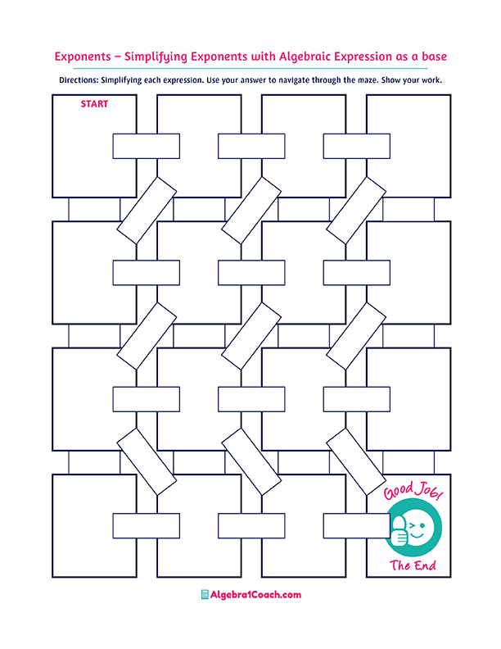
Which number is closest to the value of $\sqrt[3]{512}$?

Which number is closest to the value of $\sqrt[3]{18}$?
Which of the following is not
a perfect
cube?

$$\sqrt{676}=$$
Which of the following is not a perfect
square?

Which of the following is not
a perfect
cube?

$$4.6…$$
$$\sqrt[3]{100}=$$

$$2.6..$$

$$10.5..$$

$$144$$
$$-11$$

$$\sqrt[3]{\left(-1,331\right)}=$$

$$\sqrt[3]{216}=$$
$$±30$$

Which of the following is
a perfect
cube?

Which of the following is
a perfect
square?
$$27$$

$$9$$
$$9$$
$$64$$
$$8$$
$$90$$

$$216$$

$$512$$

What is the approximate value of $\sqrt{111}$?
$$196$$

$$225$$

$$49$$

$$\sqrt{900}=$$

$$324$$
$$624$$
$$121$$

$$441$$
$$28$$
$$±6$$
$$±15$$
$$\sqrt{225}=$$

$$11$$
$$14.6$$

$$\sqrt[3]{729}=$$

$$48$$
$$±26$$
$$14$$
$$625$$
$$12$$
$$6$$
$$126$$

