Negative Exponents
Directions: Find the correct answer. Use your answer to navigate through the maze. Show your work.
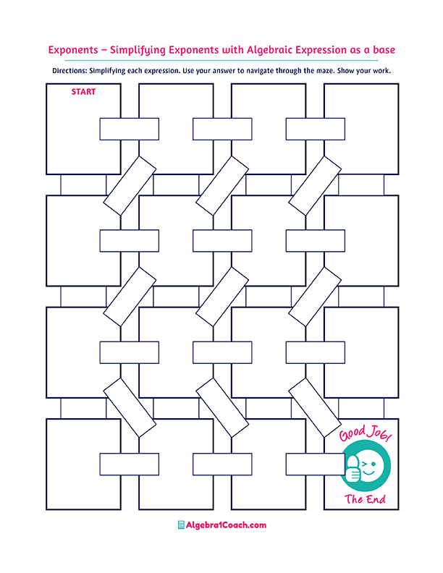
$$10$$

$$\frac{x}{16}$$

$$\frac{y^{4}}{x^{4}}$$

$$9^{0}x^{-16}=$$
$$\sqrt[3]{27}x^{-2}=$$

$${1^{-12}x}^{12}=$$
$${2^{4}x}^{-9}=$$
$$\frac{3}{x^{2}}$$

$$\frac{1}{10}$$

$$\frac{16}{x^{9}}$$
$$\frac{7}{x^{2}}$$

$$\frac{1}{{7x}^{2}}$$

$$\frac{1}{x^{16}}$$
$$\frac{{10}^{-2}}{{0.3}^{-1}}=$$

$$\frac{{3y}^{4}}{{9x}^{4}}$$

$$\frac{3x^{4}}{y^{4}}$$

$$\frac{x^{4}}{3y^{4}}$$

$$\frac{xy^{4}}{6}$$

$$\frac{6x}{y^{4}}$$

$$\frac{x}{6y^{4}}$$

$${9x}^{4}y^{8}$$
$$\frac{x^{4}y^{8}}{9}$$

$$\frac{1}{4}$$

$$\frac{{16}^{-1}}{2^{-2}}=$$
$$\frac{1}{{9x}^{4}y^{8}}$$

$$2x^{-2}y^{-5}=$$

$${\left(3x^{2}y^{4}\right)}^{-2}=$$

$$\frac{2}{x^{2}y^{5}}$$
$${\left(\sqrt{7x}\right)}^{-2}=$$
$$\frac{{10}^{-3}}{{10}^{-5}}=$$
$$\frac{1}{{6x}^{-1}y^{4}}=$$

$$2^{-4}x=$$

$${\left(\sqrt[3]{xy}\right)}^{-3}=$$

$$0.003$$
$$\frac{{9^{-1}x}^{-4}}{{3^{-2}y}^{-4}}=$$

$$\frac{6^{3}}{6^{0}}=$$
$$16x$$
$$6xy^{4}$$
$$8$$
$$x^{12}$$
$${-x}^{12}$$

$$100$$

$$216$$
$$36$$
$${2x}^{2}y^{5}$$
$$xy$$
$$\frac{x}{8}$$

$$\frac{1}{xy}$$

