Negative Exponents Operations
Directions: Find the correct answer. Use your answer to navigate through the maze. Show your work.
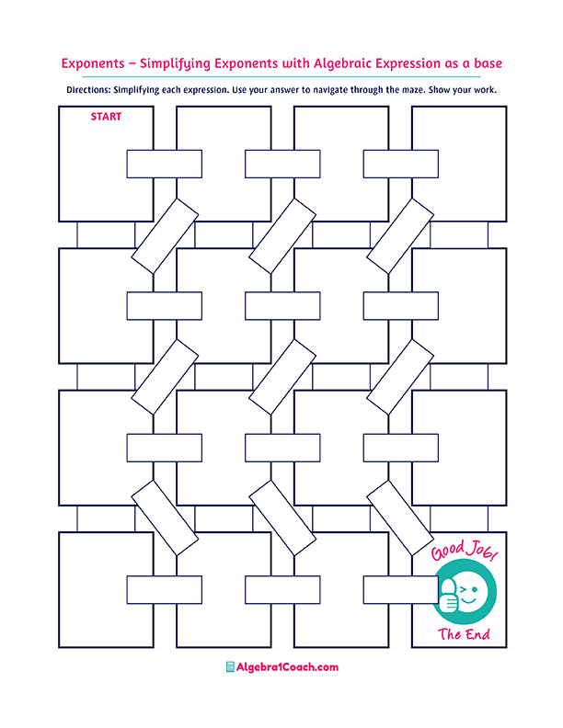
$$\frac{{2x}^{-1}}{2^{-2}x}=$$
$$27x^{5}$$

$$4$$

$$x^{3}$$
$$\frac{1}{x^{24}}$$

$$\frac{1}{x^{3}}$$

$$10$$

$$\frac{1}{4x}$$
$$\frac{{3^{-1}x}^{4}}{{9^{-2}x}^{-1}}=$$

$$\frac{25x^{2}}{9}$$

$${\left(\frac{3x}{5}\right)}^{-2}=$$
$$x^{8}$$
$${\left(\frac{{\left(x^{-3}\right)}^{-2}}{x^{2}}\right)}^{-1}=$$
$${\left(\frac{{2x}^{5}}{x^{4}}\right)}^{2}=$$

$${10}^{10}$$

$$\frac{x^{4}}{27}$$

$$\frac{x^{11}}{2}$$

$$\frac{1}{8}$$

$$\frac{{2x}^{6}×{3x}^{8}}{12x^{3}}=$$
$$x^{3}$$
$$\frac{x^{-2}×x^{-5}}{x^{-10}}=$$

$${\left(\sqrt[3]{6}x^{-2}\right)}^{3}=$$

$${x^{-12}÷x}^{12}=$$
$$\frac{6}{x^{6}}$$

$$\frac{27}{x^{5}}$$
$$\frac{y}{{4x}^{2}}$$

$$\frac{25}{9x^{2}}$$
$$\frac{1}{x^{8}}$$

$$\frac{xy^{4}}{4}$$

$$\frac{1}{x^{3}}$$

$$\frac{}{6y^{4}}$$

$$\frac{2}{8}$$

$$\frac{8}{x^{2}}$$

$$\frac{1}{x^{2}}$$

$$x^{-2}×x^{5}=$$

$${2^{3}×2}^{-1}=$$

$$\frac{{10}^{3}×{10}^{2}}{{10}^{-5}}=$$
$$\frac{x^{6}×x^{-12}}{x^{-3}}=$$

$$\frac{{\left(x^{2}y\right)}^{-2}}{4x^{-3}y^{-2}}=$$

$$4x^{2}$$
$$\frac{3^{-3}}{3^{-4}×3}=$$
$$1$$
$$8$$
$${-x}^{24}$$

$$1$$
$$0$$
$$x^{-3}$$
$$\frac{4}{xy}$$

