Name: ________________________________ Period: ____________ Date: ______________
Color Match Activity SOLVING EQUATIONS WITH DISTRIBUTIVE PROPERTY
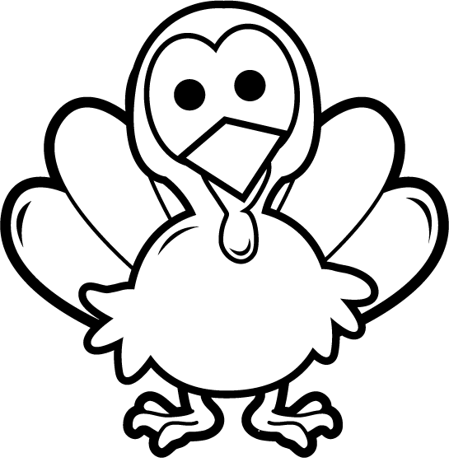
$$\frac{26}{5}$$
$$\frac{26}{5}$$
$$\frac{3}{2}$$
$$11$$
$$161$$
$$110$$
$$2$$
$$12$$
$$3a-6b$$
Distributive
Distributive

Directions: Answer the questions. Find your answer on the Thanks-Giving Turkey. Then color according to your answers.
1. The property $A\left(B±C\right)=AB±AC$ is known as __________ property. (LIGHT YELLOW)
2. $3\left(a-2b\right)=_____________$. (RED)
3. Simplifying $12-2\left(1+3\right)+4(3-1)$ gives __________. (ORANGE)
4. The solution of $3x+5(x-1)=11$ is ___________. (YELLOW)
5. Simplifying $-10+4\left(40+1\right)-44$ gives ____________. (GREY)
6. Simplifying $-10\left[-5\left(-4+7\right)\right]+11$ gives ____________. (RED)
7. The solution of $3\left(x-1\right)=2(x+4)$ is ___________. (ORANGE)

8. The solution of $4x+\frac{1}{3}\left(6x-12\right)=5$ is ___________. (GREEN)

9. The solution of $\frac{3}{8}\left(16x-64\right)=\frac{1}{2}(2x+4)$ is ___________. (BROWN)

