Name: ________________________________ Period: ____________ Date: ______________
Thanksgiving Color Match Activity CREATING LINEAR EQUATIONS
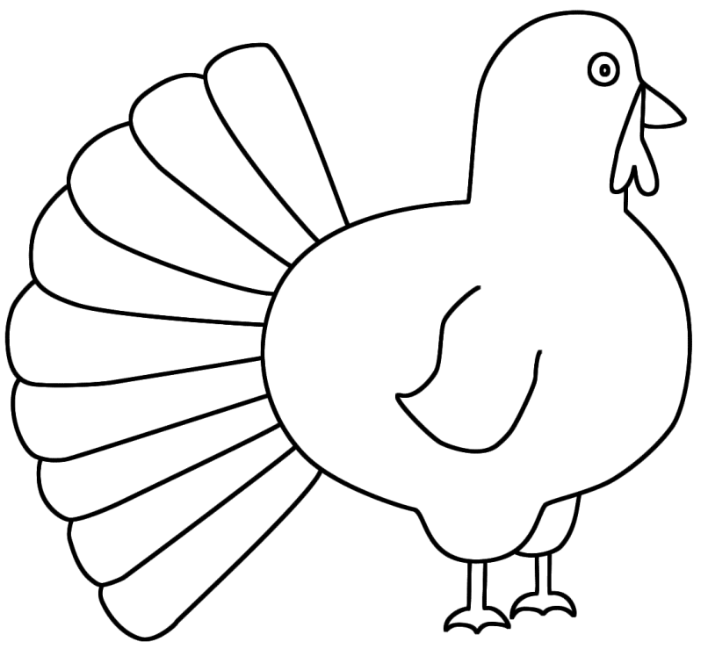
$$y=-\frac{1}{5}x+2$$
$$-25$$
$$-25$$
$$\frac{2}{5}$$
$$\frac{2}{5}$$
$$1$$
$$1$$
$$1$$
$$y=2x-5$$
$$y=5x-1$$
$$y-y_{1}=m(x-x_{1})$$

$$y-y_{1}=m(x-x_{1})$$

$$1$$
$$-2$$
$$y=mx+b$$
Linear

Directions: Answer the questions. Find your answer on the Thanks-Giving Turkey. Then color according to your answers.
1. An equation representing a straight line is known as a ________ equation. (ORANGE)
2. The slope-intercept form a linear equation is _________. (RED)
3. The slope of the equation $2y=-4x+2$ is _________. (PURPLE)
4. Write an equation in slope-intercept form for the line passing through the points
$(1,-3)$ and $\left(3,1\right).$ (YELLOW)
5. What is the slope of the line passing through the points $(1,-1)$ and $(3,1)$? (BROWN)

6. The point-slope form of the equation of a straight line is ________. (PINK)

7. Write an equation for the line passing through the points $(1,4)$ and $(2,9)$. (GREEN)
8. What is the slope of the line passing through the points $\left(2,8\right)$and$(-3,6)$? (SKY BLUE)

9. The y-intercept in the equation $4y=3x-100$ is ________. (LIGHT GREEN)
10. Write an equation for the line passing through the points $\left(5,1\right)$and$(0,2)$. (GREY)

