Name: ________________________________ Period: ____________ Date: ______________
Thanksgiving Color Match Activity EXPRESSIONS WITH RADICAL EXPONENTS
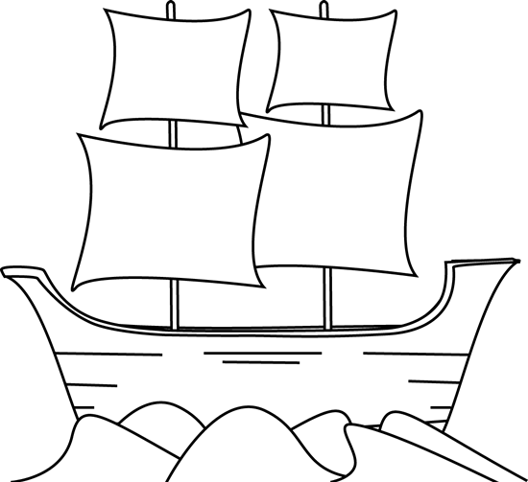
$$2o^{3}m\left(\sqrt[5]{n^{2}} \right)$$
$$1$$
$$7a^{2}b^{4}$$

$$\sqrt[9]{104.04t^{2}}$$
$$3x^{2}\sqrt[4]{y^{3}}$$
$$1/x^{n}$$

$$1$$
$$3^{\frac{2}{3}}$$
$${(a)}^{\frac{m}{n}}$$
Radical
$$\sqrt[4]{3x}$$

Directions: Answer the questions. Find your answer on the May-Flower ship. Then color according to your answers.
1. An expression having the variable under the radical sign is known as ________ expression. (YELLOW)
2. Any radical expression of the form $\sqrt[n]{a^{m}}$ can be written using a fractional exponent in the
form __________. (ORANGE)
3. The expression $\sqrt[3]{9}$ written as an expression with rational exponent is __________. (PINK)
4. The expression ${\left(3x\right)}^{\frac{1}{4}}$ written in radical form is __________. (LIGHT BLUE)

5. By the laws of exponents, $x^{0}=___________.$ (GREY)

6. By the laws of exponents, $x^{-n}=___________$ (LIGHT BLUE)

7. Simplifying the expression $\sqrt[4]{81x^{8}y^{3}}$ gives __________. (BROWN)
8. The expression ${(10.2t)}^{\frac{2}{9}}$ written in radical form is ___________. (GREEN)

9. Simplifying the expression $\sqrt[3]{343a^{6}b^{12}}$ gives __________. (GREY)
10. Simplifying the expression $\sqrt[5]{32m^{5}n^{2}o^{15}}$ gives __________. (LIGHT BLUE)

 | Answers:  - Radical  - ${(a)}^{\frac{m}{n}}$  - $3^{\frac{2}{3}}$  - $\sqrt[4]{3x}$  - $1$  - $1/x^{n}$  - $3x^{2}\sqrt[4]{y^{3}}$  - $\sqrt[9]{104.04t^{2}}$  - $7a^{2}b^{4}$  - $2o^{3}m\left(\sqrt[5]{n^{2}}\right)$

